Martock Parish
Council
Good Neighbour Befriending Scheme
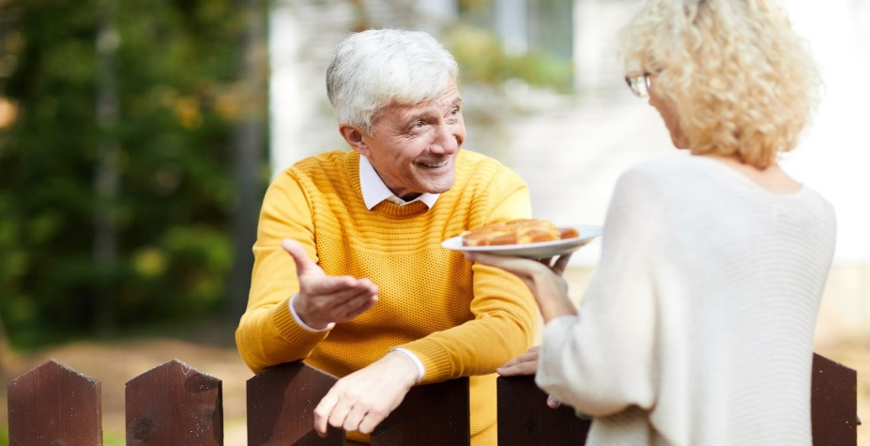
This Photo by Unknown Author is licensed under CC BY
Do you or someone you know feel isolated or lonely?
There are many reasons why someone may feel this way, it may be due to ill health, bereavement, disability or poor mobility. A caring responsibility, no family, a busy family or loved ones that live away. Feelings of isolation and loneliness are not age related and can affect people of all ages.
A volunteer befriender offers regular time and companionship and an opportunity for:
- A cup of tea and a chat.
- A friendly face to accompany you to a local group or activity.
- Someone to share a hobby with or to start a new one and much more….

If you have a little time to spare and you wish to volunteer as a befriender, please contact Caroline on
07946 121 612 or caroline.bennett@martock-pc.gov.uk

