Martock Parish
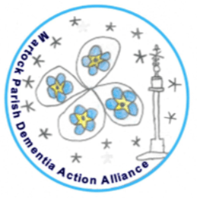
Council

Martock Parish Dementia Action Alliance

We are working towards a Dementia Friendly Community

To find out more please contact:
Caroline Bennett on 07946 121 612
Caroline.bennett@martock-pc.gov.uk

