**Martock Parish**

**Council**

**Supporting seniors in our community**



A friendly approach to assisting Martock Parish senior residents to access services; address issues of social isolation, health and well-being and to enable and support seniors to be independent.

My usual working days are Tuesday, Wednesday and Thursday

If you would like more information regarding the service, or are interested in volunteering with a group or as a befriender, please contac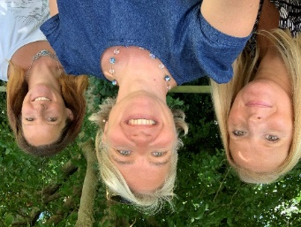t

**Caroline Bennett**

(Seniors Support Coordinator)

**07946 121 612 or** [carolinebennett@martock-pc.gov.uk](mailto:carolinebennett@martock-pc.gov.uk)