**Elevenses**

**at Bearley**

Come and join us for a friendly cuppa

An opportunity to have a natter with your neighbours



**First Tuesday of the month**

**11-12am**

**Bearley House Lounge**

**Please come and join us for a cuppa!**

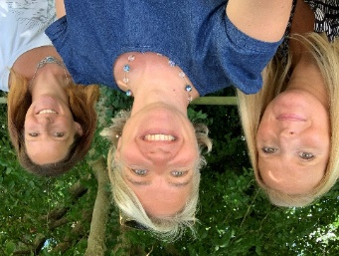

Caroline Bennett

Martock Community Team

07946 121 612, [caroline.bennett@martock-pc.gov.uk](mailto:caroline.bennett@martock-pc.gov.uk)

